DGAC

Runway Surface Conditions Assessment and Reporting

Paris, France 31 March and 1 April 2016

How to address the issue of fixing Maintenance/Minimum Friction levels of a runway?

Minimum Friction Level [Number, Index, Matrix]?

(Presented by Armann Norheim, Rapporteur ICAO Friction Task Force)

SUMMARY
The purpose of this information paper is to provide a discussion based upon factual information given in an Information Paper. In addition there is prepared a power point presentation to be presented at the Symposium. All three documents is a package to address; how to address the issue of fixing Maintenance/Minimum Friction levels of a runway?

1. INTRODUCTION
1.1 ICAO – Surface friction characteristics – minimum friction level set by the State
1.1.1 The ICAO Annex 14, Volume I, 6th Edition, July 2013:

3.1.23 A paved runway shall be so constructed as to provide surface friction characteristics at or above the minimum friction level set by the State.

10.2.3 A paved runway shall be maintained in a condition so as to provide surface friction characteristics at or above the minimum friction level specified by the State.

10.2.4 Runway surface friction characteristics for maintenance purposes shall be periodically measured with a continuous friction measuring device using self-wetting features and documented. The frequency of these measurements shall be sufficient to determine the trend of the surface friction characteristics of the runway.

10.2.5 Corrective maintenance action shall be taken to prevent the runway surface friction characteristics for either the entire runway or a portion thereof from falling below a minimum friction level specified by the State.
1.1.2 The ICAO Annex 14, Volume I, 7th Edition, July 2016 (To be published):

2.9.9 Information that a runway or portion thereof is slippery wet shall be made available.

Note 1.— The surface friction characteristics of a runway or portion thereof can be degraded due to rubber deposits, surface polishing, poor drainage or other factors. The determination that a runway or portion thereof is slippery wet stems from various methods used solely or in combination. These methods may be functional friction measurements, using a continuous friction measuring device, that fall below a minimum standard as defined by the State, observations by aerodrome maintenance personnel, repeated reports by pilots and aircraft operators based on flight crew experience or through analysis of aeroplane stopping performance that indicates a substandard surface. Supplementary tools to undertake this assessment are described in the PANS-Aerodromes (Doc 9981).

1.1.3 PANS-Aerodromes (Doc 9981) (Revised-to be published):

1.1.1.1 Assessing and reporting the condition of the movement area and related facilities is necessary in order to provide the flight crew with the information needed for safe operation of the aeroplane. The runway condition report (RCR) is used for reporting assessed information.

1.1.1.2 On a global level, movement areas are exposed to a multitude of climatic conditions and consequently a significant difference in the conditions to be reported. The RCR describes a basic structure applicable for all these climatic variations. Assessing runway surface conditions rely on a great variety of techniques and no single solution can apply to every solution.

Table 3 – Assigning a runway condition code (RWYCC) (extract)
Runway condition description | Runway condition code  (RWYCC)
WET (“Slippery wet” runway) | 3

Attachment A – Methods of assessing runway surface conditions – see page 15.

2. DISCUSSION
2.1 Mu-Meter Aircraft Pavement Rating – (United States)
2.1.1 In the Information Paper (IP), MU = 0.50 as measured by a Mu-Meter, factual information is provided. This DP will make reference to paragraphs in that IP identified by [n.nn.n].
2.1.2 The information paper shows how a Mu-Meter reading of 0.50 was arrived at [2.9.2][Figure 3], averaged from five to seven tests on a 2000 feet long test area. [2.9.6]

2.1.3 With the caveat of being somewhat arbitrary, a rating system was developed [2.9.5][Figure 4]. From this rating system we find that above 0.50 the expected aircraft braking response is good and that no hydroplaning problems are expected. We also find that for the 0.42 value the expected braking action is expected to be to be fair above with a transitional response and marginal expected braking response below 0.42 with potential for hydroplaning for some aircraft under certain wet conditions.

MU-METER AIRCRAFT PAVEMENT RATING
MU | Expected Aircraft Braking Response | Response
> 0.50 | Good | No hydroplaning problems are expected
0.42 – 0.50 | Fair | Transitional
0.25 – 0.41 | Marginal | Potential for hydroplaning for some a/c exists under certain wet conditions.
< 0.25 | Unacceptable | Very high probability for most aircraft to hydroplane.

2.1.4 In 1975 when FAA published their first version of Advisory Circular No. 150/5320-12 the Mu-Meter 0.50 value was related to a Minimal Average Friction Requirement for Runway Pavements expressed as an AVERAGE WET MU VALUE, averaged over 1000 ft increments [2.9.10].

2.1.5 In 1986, the AC No. 150/5320-12A refers to a Mu-Meter Mk4 and the averaged Mu value of 0.50, at speed 40 mph (65 kmh) was kept but now evaluated over three different lengths, 500 ft, 1000 ft and 1500 ft [2.9.16]. Correlation chart to three other friction measuring devices were provided [2.9.18]. A second and higher speed, 60 mph (97 kmh) with associated evaluation criteria was introduced [2.9.17].

2.1.6 In 1991, the AC No. 150/5320-12B introduces classification levels and we find that to the Mu-Meter Mk4 a Maintenance planning level of 0.52 and a Minimum level of 0.42 is assigned [2.9.21].

2.1.7 Prior to publication of 12B the E-17 committee of American Society for Testing and Materials (ASTM) requested the FAA to conduct tire performance tests on two tires manufactured according to ASTM standards. The numbers assigned to the Mu-Meter Mk4 are derived from the testing that was performed and published. [2.9.22][2.9.23].

2.1.8 The published tire test report does not clarify how the minimum friction level was arrived at, but we find the 0.42 value at the lower end of the Mu-Meter Aircraft Pavement Rating table representing Fair expected aircraft braking response and a transitional response regarding hydroplaning potential. It should be a rather safe assumption that the Mu-Meter Aircraft Pavement Rating has been part of arriving at this value.

2.1.9 This assumption is also close to the recommendation of ICAO FTF (and TALPA ARC) regarding assigning the “slippery when wet” term to aeroplane performance via a new term called Runway Condition Code. [2.11.3]. The assigned aeroplane performance level is in a new Runway Condition Assessment Matric (RCAM) aligned to a Downgrade Assessment Criteria describing Aeroplane Deceleration Or Directional Control Observation as Braking deceleration is noticeably reduced for the wheel braking effort applied OR directional control is noticeably reduced and which is aligned to Pilot Braking Action Advisory Report MEDIUM. MEDIUM represents FAIR in the Mu-Meter Aircraft Pavement Rating table.

2.1.10 In this context it should be noted that the Minimum Friction Level and Slippery When Wet has caused lengthy discussions which have been blurred with arguments from previous discussions arising from various basic assumptions. With the approach above we kind of cut clear of all these discussions since we refer to a table where the origin of both 0.50 and 0.42 values are known. With the now established relationship between a WET (“Slippery wet” runway) and a RWYCC we do have a link to the aircraft not unlike to the one expressed in the Mu-Meter Aircraft Pavement Rating table from 1973 [2.9.5][Figure 4].

2.1.11 The change from 0.50 to 0.52 can be explained by the outcome from the tire testing program [2.9.22].

2.1.12 In 1997 the AC No. 150/5320-12C reflects the same 0.52 and 0.42 values assigned to the Mu-Meter.

2.1.13 The best course of action seems to be to link the Minimum Friction Level to the Mu-Meter with a value of 0.42 as measured by Mu-Meter Mk (as used in the Joint USAF/NASA/FAA project).

2.1.14 The Mu-Meter also serve as the historical basic reference friction device, consequently the same type of device is the reference in US and UK and linked to the minimum friction level and thereby to “slippery when wet”,

2.1.15 To improve this situation the best course of action might be to have a full scale project involving aircraft, Mu-Meter (1970’s), Mu-Meter (today’s version), Reference device (chosen by European States). Such a project could link the basic assumption for existing system with today’s system (US) and the technology of today’s aircrafts. This would account for the technology improvement from the aircrafts of 1970’s (B-727 and DC-7) [2.9.3].

2.2 Accuracy vs uncertainty

2.2.1 Through numerous research projects both at runways and roads the lesson has been learned as expressed through the ROSANNE project [2.12.7]: Recognising that previous exercises to harmonise measurements have not been able to do so to a sufficient level of precision ….. the precision required for the Common Scale and the method of analysis use to define the Common Scale.

2.2.2 Regarding the ROSANNE project it has been found that to refine the level of precision a need for a pragmatic approach to renounce (provisionally) to the concept of a single friction index and go to a two parts standard, one part for the definition of a sideways force coefficient (transverse friction index), the second for the definition of a braking force coefficient (longitudinal friction index).

2.2.3 Lesson learned from the annual NASA tire/runway friction workshops is that wet surface evaluation for hydroplaning requires a minimum of three speeds [2.10.7].

2.2.4 Another lesson learned from the 15 years of data from the NASA workshops is that the same friction measuring devices operated by different organisations produced different friction readings for the same surface/wetness/speed condition [2.9.24].

2.2.5 Lesson learned from the EASA RuFAB project is that: [2.11.1]
- Evaluation of 14 different harmonisation methods, alone or in combination was not believed to be acceptable for general use. Two main reasons were given:
  - Repeatability and reproducibility of the devices
  - Imperfect numerical models
- Friction measuring devices are not time-stable
- Existing harmonisation models (2010) do not guarantee that the friction estimate obtained can be correlated to actual aircraft braking performance.

2.2.6 This knowledge, together with the fact that a stable reference do not exist dictates that we cannot deal with precision expressed by accuracy but have to manage uncertainty. Further the knowledge makes us aware that the system in place today is a flawed system. Gradually an acceptance comes that the information we are searching cannot be expressed by a single number. Thus the Mu-Meter (1970’s) 0.50 and 0.42 values is not enough information. A broader approach needs to be taken to meet the regulatory requirement given by the ICAO Annex 14, Vol. I Standard:

3.1.23 A paved runway shall be so constructed as to provide surface friction characteristics at or above the minimum friction level set by the State.

The focus is on the surface friction characteristics.

2.3 Conceptual approach

2.3.1 The surface friction characteristics can be approached in two ways

1. When designing and constructing the pavement

2. When maintaining the pavement

2.3.1 When designing and constructing the pavement qualities defining the surface friction characteristics are built into the pavement surface. These are qualities that can be controlled on the different components that form part of a pavement or tools used for its surface treatment. These are components that can be part of the contractual documents.

2.3.2 A conceptual approach can be that part of the delivery should be a description of the surface friction characteristics that shall be published in the AIP.

2.3.3 Such description would then be a reference for the trend monitoring (comparative). The tools for such trend monitoring of the surface friction characteristics is what we in fact are searching for and the outcome from these tools is what defines the minimum friction level, consequently we are in search of Minimum Friction Level [Matrix] to be used for pavement management. We should with care and consideration look into such an approach.

2. 4 Trend monitoring

2.4.1 Trend monitoring concept

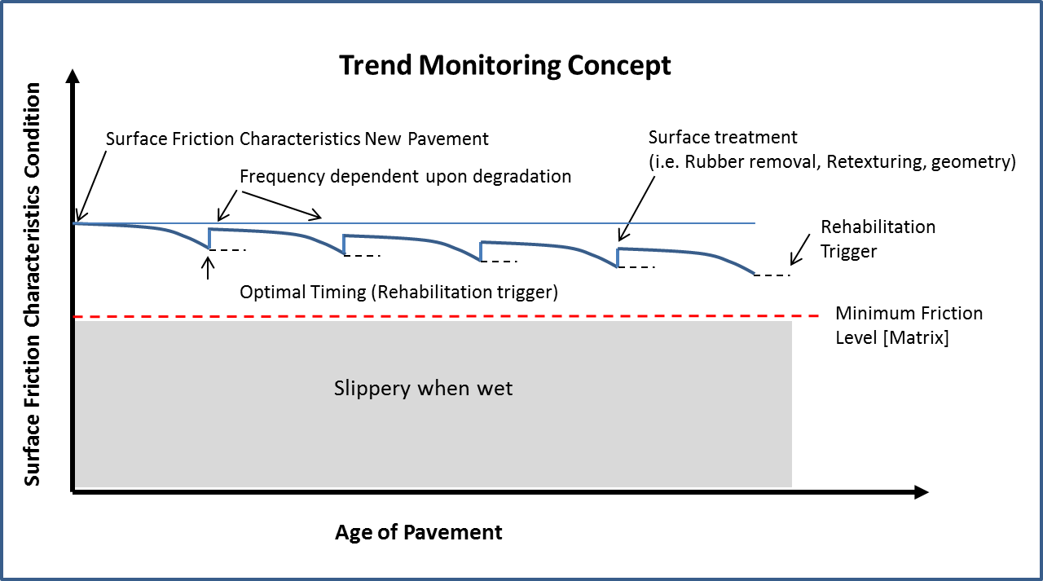

2.5 Another perspective

2.5.1 United Kingdom and United States has had a domination role when developing the concept’s used today. These concepts’ is based upon technologies and procedures with known shortcomings and limitations. It might be useful to useful to try to view at the problem from another perspective.

2.5.2 Another broad perspective (also includes roads) is represented in a Australian – African perspective where a concept with the analogy of four legs of a table is presented in a conference paper (1). If any of the legs of a four leg table is missing, the table will get unstable:

1. Geometry

2. Macro texture

3. Skid resistance

4. Runway End Safety Areas (RESA)

2.5.3 In this paper, we are dealing with the surface of the runway; we can therefore leave out the 4th leg. In our analogy we can still have a stable situation if the table is built to be supported by three legs.

2.6 Leg 1 - Geometry

2.6.1 Geometry deals with the longitudinal and transverse slopes of the runway. This geometry, in combination with prevailing climatic conditions defines the drainage capability of the pavement. The geometry of the runway which should be such that its longitudinal and transverse alignment is without undulations or depressions; otherwise water can pond when wet.

2.6.2 Ponding is easily detectable by the eye and do not represent to much challenge to measure. Depth and extent of ponds can easily be measured and we can use the metre as defined in the International System of Units (SI).

2.6.3 Measurement of slopes and measurement with straightedges does not represent much challenge as there are readily available and defined standards for distances and slopes. For that reason geometry is not further commented in this document.

2.7. The two remaining legs Macro texture and Skid resistance does cause more of a challenge. The challenge is lack of ISO standards of measurement, or to agree/standardise upon those measuring methods available.

2.8 Leg 2 - Macro texture

2.8.1 FAA Advisory Circular No. 150/5320-12, all versions, describes the NASA Grease-Smear technique for measuring pavement surface texture depth.

2.8.2 US Navy, in their 1981 NAVFAC Design Manual DM-21.9 Skid Resistant Runway Surfaces (2), describes the same NASA Grease-Smear technique.

2.8.3 ICAO Doc 9137, Part 2 – Airport Services Manual describes in para. 2.3 the Grease Patch Method and the Sand Patch Method. In Appendix 2 the Grease Patch Method is described in detail. ICAO Doc 9137 does not describe how these two methods relate to each other.

2.8.4 Both methods are recognised as volumetric techniques which give the texture as millimetre (mm) Mean Texture Depth (MTD).

2.8.5 For the Sand Patch Method there existed an ASTM E 965-96(2006) standard. However this standard were withdrawn recently (2015) with no replacement.

2.8.6 The Sand Patch Method is described in a CEN EN 13036-1 standard (3). This has been reviewed in 2014 and is approved for another five year period. There is no ISO standard developed. The CEN standards are “nationalised” and a preview of part of the Austrian version of the standard is available on the Internet.

2.8.7 The Sand Patch Method is using standardised solid glass spares as sand.

2.8.8 For the Grease Patch method there is no standard developed. However discussion on how the NASA grease specimen technique and the sand patch method relates to each other can be found in ASTM STP 763 (1982) (4)

2.8.9 In 1983 NASA published the Technical Memorandum Factors influencing aircraft ground handlings performance (5). At page 21 of this document following table appears:

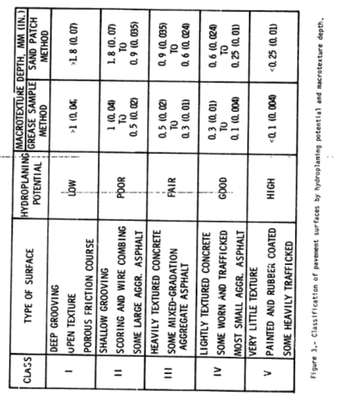

2.8.10 In a presentation, Pavement Texture – The Key Player in Tire Friction Performance by Thomas Yager at the Airfield Engineering and Asset Maintenance 2012 (5) the same table appears but now with the inclusion of a relationship to measurements by the Outflow Meter.

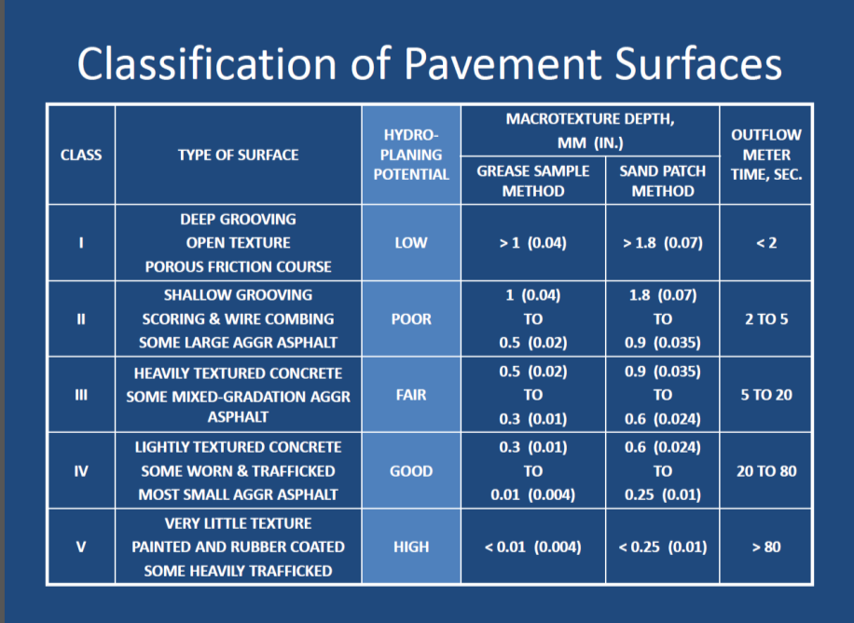

2.8.11 ESDU in their 1971 Engineering Sciences Data Unit ESDU 71026 Frictional and retarding forces on aircraft tyres. Part II: estimation of braking force does not distinguish between the volumetric methods. The title of Figure 2a in this document reads:

Classification of runway surfaces: Texture depths measured by grease and sand patch methods.

In ESDU 71026 revision D dated 1995 the Figure 2a has been given a new layout, but expanded to include more surfaces, but the same title has been kept. However preference has been given to the grease method (6).

2.8.12 ICAO discussed the subject at the Aerodromes, Air Routes and Ground Aids Divisional Meeting in 1981 (AGA 81):

There was less agreement on recommending use of either the grease or sand patch measuring techniques. It was recognized by all, that although far from exact, these were the most suitable methods available and were in general use. The results from recent tests showed a correlation between the two methods but also showed values using the grease patch method to be lower than those using the sand patch method. It was agreed therefore the reference to these methods should only be made in a note (7).

2.8.13 Even though a relationship has been established between the two volumetric (MTD) methods there is no universal agreement on this. Both methods are being claimed to be dependent upon the person who perform the measurements. However, it can be documented that research activities in US has used the NASA grease method and further that the ESDU has a preference towards this method. If reference to this earlier research activities is of importance an agreement should be reach upon which relationship should be used. Alternatively a new baseline should be established using up to date measuring techniques.

2.8.14 Another critique of the volumetric method is that it is a spot measurement method and a continuous method would be preferable.

2.8.15 Measurement methods of texture has gone through a paradigm shift and methods using laser measurements measuring a profile has been developed. This method perform continuous measurement. A group of ISO standards has been developed. (8), (9), (10), (11), (12)

2.8.17 The ISO standards has been developed within a “road environment” and may not be directly or only partly be representative for use within aviation at runways.

2.8.18 There is a need, within aviation, to come to an agreement with respect to measurement techniques for texture measurement.
- The necessity to establish a relationship between the NASA grease method used in basic research and the CEN EN 13036-1 standard should be agreed upon.
- Use of the ISO 13473 series standard for Characterization of pavement texture by use of surface profiles should be considered for use within aviation.

2.8.19 Norway has established a relationship, published in two reports (13), (14) for a group of laser devices at a dedicated test track with various surfaces and found a correlation factor between these devices. The CEN EN 13036-1 and ISO 13473 standards were used. Abstract from the two reports are contained in the EASA RuFab Volume 2 report Documentation and Taxonomy (15), page C3-23 to 27. Relationship MTD vs. MPD is device type dependent.

2.8.20 Texture can give information of the drainage capability but cannot be directly linked to skid-resistance. The shape of the aggregates play a role.

2.9 Leg 3 – Skid resistance

2.9.1 The difficulties experienced regarding the numerous experiments/research regarding harmonisation of friction measuring devices, which in principle began at that point in time when there were more than one device can be expressed with the state-of-the-art as expressed through the ROSANNE project. See 2.2.1 and 2.2.2 above.

2.9.2 A 2005 (16) paper, How do you compare? Correlation and calibration of skid resistance and road surface friction measurement devices, from Transport Research Laboratory, outlining the method used in UK where the SCRIM devices are harmonised annually as a group, and from which is quoted:

It is not possible to define an absolute value for skid resistance. Rather, at any particular time, the “correct” result can only be estimated and arguably the best estimate for any particular type of measurement device would be the average value given by all machines of that type. For UK SCRIMs, that would be the average of all acceptable machines in the UK fleet.

With this exercise the uncertainty involved is managed and reduced for a homogenous fleet of devices.

2.9.2 Managing uncertainty is the best course of action one can take when managing and operating a fleet of friction measuring devices. From the perspective of ICAO, it is the fleet of devices used on a world-wide basis. From the perspective of EASA it is a regional basis involving the friction measuring devices used by Member States. One of these States, France has developed a system where the uncertainty is managed by the State with a non-homogenous fleet of devices.

2.9.3 The French system is presented in two separate papers which address agenda item 2 and 3 for this meeting:
- Correlation of self-wetting continuous measuring equipment (17)
- Competency management system developed by the STAC (18)

The essence in these two papers is that uncertainty can be managed and reduced if addressed properly and a reference device is agreed upon and a competency management system developed for personnel performing runway friction measurements.

2.9.4 Another quality with the French approach is that the devices, operated by specialized laboratories performing measurements at different airports are able to compare from airport to airport and thereby ensuring uniformity.

2.9.5 The French methodology, almost a decade old, make reference to the following ISO Standards:
- ISO 17025 – General requirements for the competence of testing and calibration laboratories, (19).
- ISO 17043 – Conformity assessment – General requirements for proficiency testing, (20)

when referring to correlation of self-wetting continuous measuring equipment and for a Competency management system a system developed by the STAC is proposed to be adopted as EASA guidance as an alternative to the robust framework requiring a heavy organization structure in compliance with

- ISO 9001 – Quality management (21)

2.9.6 The French use the IMAG as a reference device. This device took part in the PIARC International Harmonisation Experiment [2.12.1][2.12.2]. However there is no relationship established towards the Mu-Meter 0.50 basic reference. If such a relationship were to be established the French methodology would bridge both ongoing work within US (Annual workshops at Penn State, [2.11.2] and the European EU funded ROSANNE project, [2.12.7].

2.9.7 The IMAG was also proposed as an International Reference Vehicle (IRV) in the Joint Winter Runway Friction Measurement Program.

2.9.8 Regarding EU funding, it should be noted that EU has funded projects, either completely or part of, for a considerable amount, [2.12.5]. In addition there are other projects in US and Canada.

2.10 Leg 4 – Runway End Safety Areas (RESA)

2.10.1 Runway End Safety Areas (RESA) does not include the runway and consequently not part of the focus of this document. However, RESA, as the fourth leg, needs to be taken into account when performing risk assessments.

2.10.2 The concept behind the RESA can be traced back to early 1960’s and the development of proposed and (unpublished FAA) special civil air regulation SR-422C. (22)

2.10.3 In 1964 a note was added to ICAO Annex 14 4th Edition to paragraph 1.10 Length of strips: Risk to passengers and damage to aircraft overrunning the runway or stopway may be substantially reduced by the provision of a cleared area beyond the end of the strip twice the width of the runway or wider where feasible. There was no agreement on the length of the RESA. (22)

2.10.4 Exposure for over-running. In 1966 ICAO Airworthiness Committee in an informal meeting ( September 12th to 15th) the Meeting considered that action on this matter involved other Divisions of ICAO and the contribution which the Airworthiness Committee could make were to point to the frequency with which aircraft do over-run and on occasions by considerable distance. The Committee could give more precision to this by preparing data on current over-run rates and the variability of over-run distances on abandoned take-offs and landings.

2.10.5 Consequence of over-running. The information on over-running could be put to the Air Navigation Commission with the view that some action is necessary to deal with the over-running. This might either be by arresting or de-lethalisation of over-run areas. The Air Navigation Commission approved this approach in 1967.

2.10.6 Area to be considered. At the ICAO AGA 81 Meeting; statistical data for landing operations of commercial air transport aircraft in the US over a 16 year period show that approximately 90 per-cent of the undershoots and overshoots occurred within 300 m of the runway end. More precisely, of 114 overruns and undershoots during 69,000,978 landings, 102 remained within an area extending 300 m, with a width of 150 m, from the runway end. It was deemed that the 90 percent coverage provided by the aforementioned area is a reasonable practical limit for several reasons. First, the area required to achieve each additional percent of coverage above 90 percent is quite large and geometrically increasing in size for each one percent increment. Secondly, for runways equipped with a localizer for approach guidance, the instrument is frequently located at a distance of 300 m from the threshold for optimum operations. It would appear that, in this situation, the Runway End Safety Area, for all practical purposes ends at the localizer.

2.11 Minimum Friction Level [Number, Index, Matrix]

2.11.1 A conceptual approach using the analogy of a stable table has been used. Addressing the runway surface friction characteristics the analogy of a three leg table has been used. Addressing risk assessment the analogy of a four leg table has been used. If a leg is missing, we will not have a stable table.

2.11.1 The approach, trying to express the Minimum Friction Level as a single number, is now widely recognized not to meet the criteria for precision needed. It is recognized that more information is needed to manage the uncertainty. Consequently we leave the alternative of one single number out.

2.11.2 There are many definitions of what an index can be, it all depends on the subject it relates to. One is found in the Oxford online dictionary:

A number giving the magnitude of a physical property or other measured phenomenon in terms of a standard:

Another one from the Mariam-Webster online dictionary:

Something (as a physical feature or a mode of expression) that leads one to a particular fact or conclusion.

2.11.3 Index can be used but do have a strong resemblance with a number; we can keep the door open for use of an index to express this “something” that leads to a particular fact or conclusion. This something must than address the three legs in our analogy.

2.11.4 Oxford online dictionary defines Matrix as:

A grid-like arrangement of elements; a lattice.

Mariam-Webster:

Something (such as a situation or a set of conditions) in which something else develops or forms.

2.11.5 Matrix can be used – set of conditions – and we can summarise our analogy of the three leg table above as follows for a wet runway case:

Wet Runway – Minimum Friction Level – Slippery when wet – Hydroplaning potential
1. leg | 2. leg | 3. leg
Geometry | Makro texture | Skid resistance
Drainage – flow by gravity | Drainage flow by gravity and forced flow at tyre/pavement interface | Drainage/Penetration of thin water film on aggregates
- Known and managed technology for measurements.  - Defects (ponding) easily detectable by the eye.  - A series of EN standards exist for aggregates | - Historic research based on NASA grease smear method (MTD).  - CEN standard exist for (MTD)  - Established relationship between the two methods but not universally agreed.  - ISO standards exist for continuous profile measurement (MPD) | - Previous harmonisation experiments has not provided desired precision.  - Uncertainty needs to be managed and ISO standards exist for management.  - France has developed a system managing uncertainty using a reference device.  - A competency management system developed by STAC is proposed.

Challenge
- No special challenge  - EN standards exist | - Decide upon standards to be used. CEN, ISO  - Relationship between MTD and MPD is device type dependent  - Shape of aggregates | - No stable reference.  - Devices not time stable  - Managing uncertainty  - Uncertainty still not at a desired level of precision.  - Competency operators  - Compare across various runways.

3. CONCLUSION

3.1 Aspects of surface friction characteristics and minimum friction level set by the State has
been presented in an Information Paper and discussed in this Discussion paper. In addition a power point presentation is prepared to be presented at the Meeting 25. March.

3.2 All three documents, as a whole give a rather detailed information of part of the history of
the MFL. The information given aims at giving broad information on the basic information that constitutes the Surface Friction Characteristics that is part of a Minimum Friction Level.

3.3 The Minimum Friction Level has been proposed as a Minimum Friction Level [Matrix].

3.4 This Minimum Friction Level [Matrix] is further detailed in the power point presentation.
This presentation aims at extracting information from the Information paper and Discussion paper and sees this in light of historic and proposed reporting regime.

Attachment A to Chapter 1, Section 1.1

METHODS OF ASSESSING RUNWAY SURFACE CONDITION

 |  | ANNEX 14 Vol I, 6 ED, July 2013 | REMARK
DESIGN AND CONSTRUCTION | slope | 3.1.13 Longitudinal slopes  3.1.19 Transverse slopes
 | Texture | 3.1.26 Recommendation.—The average surface texture depth of a new surface should be not less than 1.0 mm.
 | Minimum friction level set by the State | 3.1.23 A paved runway shall be so constructed as to provide surface friction characteristics at or above the minimum friction level set by the State. | The State set criteria for surface friction characteristics and output from State set or agreed assessment methods form the reference from which trend monitoring are performed and evaluated.
 | Polishing | 3.1.23 A paved runway shall be so constructed as to provide surface friction characteristics at or above the minimum friction level set by the State. | Polished Stone Value. (PSV-value) is a measure of skidding resistance on a small sample of stone surface, having being subjected to a standard period of polishing.
 |  |  | Rubber build-up | Geometry change | Polishing
ASSESSMENT METHODS FOR MONITIORING TREND OF CHANGE TO SURFACE FRICTION CHARACTERISTICS | Visual - macrotexture | Visual assessment will only give a very crude assessment of the macrotexture. Extensive rubber buil-up can be identified. | X
 | Visual - microtexture | Visual assessment will give a very crude assessment of the microtexture and to what degree the microtexture has been has been filled and covered by rubber. | X
 | Visual – runway geometry (ponding) | Visual assessment during a rain storm and subsequent drying process of the runway will reveal how the runway drains and if there has been any changes to runway geometry causing ponding. Depth of any pond can be measured by a ruler or any other appropriate depth measurement method/tool. |  | X
 | By touch - macrotexture | Assessment „by touch“ can differentiate between degree of loss of texture but not quantifying it. | X
 | By touch - microtexture | Assessment „by touch“ can identify if microtexture has been filled in/covered by rubber-build up. | X
 | Grease smear method (MTD) | Measure a volume – Mean Texture Depth (MTD) primarily by using the grease smear method, is the measurement method used for research purposes related to aeroplane performance. | X
 | Sand (glass) patch method (MTD) | Measure a volume – Mean Texture Depth. The sand (glass) patch method are not identical to the grease smear method. There is at present no internationally accepted relationship between the two methods. | X
 | Laser – stationary (MPD) | Measure a profile – Mean Profile Depth (MPD). There is no established relationship between MTD and MPD. The relationship must be established for the laser devices used and the preferred volumetric measurement method used. | X
 | Laser – moving (MPD)
 | Friction measurement – controlled applied water depth | A friction measurement is a system output which includes all the surface friction characteristics and characteristics of the measuring device itself. All other variables than those related to the surface friction characteristics must be controlled in order to relate the measured values to the surface friction characteristics.  The system output is a dimensionless number which is related to the surface friction characteristics and as such is also a measure of macrotexture. (The system generated number needs to be paired with other information (assessment methods) to identify which surface friction characteristics that significantly influence the system output.)  It is recognised that there is currently no consensus within the aviation industry how to control the uncertainty related to repeatability, reproducibility and time stability. It is paramount to keep this uncertainty as low as possibly, consequently ICAO has tightened the standards associated with use of friction measurement devices, including training of personnel who operates the friction measuring devices. | X |  | X
 | Friction measurement –  Natural wet conditions | Friction measurements performed under natural wet conditions during a rain storm might reveal if portions of a runway are susceptible to ponding and/or to fall below State set criteria. | X | X | X
 | Modelling of water flow and prediction of water depth | Emerging technologies based on the use of a model of the runway surface describing its geometrical surface (mapped) and paired with sensor information of water depth allow real-time information and thus a complete runway surface monitoring, and anticipation of water depths. |  | X

4. REFERENCES

- Horak, E., Emery, S., and Morton, B., Roughening up a wet pavement surface!, 4th SARF/IRF Regional Conference for Africa, Somerset West, South Africa. 11-13 Oct. 2010.
- Anonymous, NAVFAC Design Manual DM-21.9, Skid Resistant Runway Surfaces, Naval Facilities Engineering Command, Alexandria, VA 22332, United States. Dec. 1981.
- CEN, EN 13036-1:2010, Road and airfield surface characteristics. Test methods. Measurement of pavement surface macrotexture depth using a volumetric patch technique. 30 June 2010
- Yager T.J., and Buhlmann, F., Macrotexture and Drainage Measurements on a variety of Concrete and Asphalt Surfaces,” ASTM STP 763, ASTM, 1982
- Yager, T.J., Pavement Texture – The Key Player in Tire Friction Performance, Presented at Airfield Engineering and Asset Maintenance 2012, Asiaworld Conference-Expo, Hong Kong, 19-22 June 2012.
- Personal information by the researcher/author at an ESDU meeting.
- ICAO, Aerodromes, Air Routes and Ground aids Divisional Meeting, Montreal, 1981.
- ISO 13473-1:1997(en), Characterization of pavement texture by use of surface profiles – Part 1: Determination of Mean Profile Depth, 1997, last reviewed in 2013.
- ISO 13473-2: 2002(en), Characterization of pavement texture by use of surface profiles – Part 2: Terminology and basic requirements related to pavement texture profile analysis, 2002. Last reviewed in 2013.
- ISO 13473-3:2002(en), Characterization of pavement texture by use of surface profiles – Part 3: Specification and classification of profilometers, 2002. Last reviewed in 2013.
- ISO 13473-4:2008(en), Characterization of pavement texture by use of surface profiles – Part 4: Spectral analysis of surface profiles, 2008
- ISO 13473-5:2009(en), Characterization of pavement texture by use of surface profiles – Part 5: Determination of megatexture, 2009
- Andresen, A., Holshagen, B., Lange, G., and Norheim, A., Comparison of Pavement Texture Measurement Systems, Technical Report No.: OKK 2003-1, Avinor, Oslo, Norway 2003.
- Andresen, A., Holshagen, B., Lange, G., and Norheim, A., Results from the International Texture Workshop 2003, Technical Report No.: OKK 2003-2, Avinor, Oslo, Norway, 2003.
- Comfort, G., Rado, Z., Townshend, T., and Mazur, A., RuFAB – Runway friction chacteristics measurement and aircraft braking, Volume 2, Documentation and Taxonomy, Research project EASA.2008/4, BMT Fleet Technolgy Ltd, Kanata, ON, Canada, March 2010.
- Roe, P. G., and Sinhal, R., How do you compare? Correlation and calibration of skid resistance and road surface friction measurement devices. Surface friction conference, New Zealand Transport Agency, 2005, PA/INF/4522/05, TRL Limited, 2005.
- Gerthoffert, J., Correlation of self-wetting continuous friction measuring equipment, Thematic Meeting on “Runway Minimum Friction Level, Cologne, Germany, 15 March 2015.
- Gerthoffert, J., Competency management system developed by the STAC, Thematic Meeting on “Runway Minimum Friction Level, Cologne, Germany, 15 March 2015.
- ISO/IEC 17025:2005, General requirements for the competence of testing and calibration of laboratories, last reviewed in 2010.
- ISO/IEC 17043:2010, Conformity assessment – General reqirements for profiency testing.
- ISO 9001:2008, Quality management systems – Requirements, 2008.
- ICAO State Letter AN 4/5-64/166 19 Nov.
- ICAO Aerodromes, Air Routes and Ground Aids Divisional Meeting, Montreal, 22 Apriul – 15 May 1981. Doc 9342, AGA/81.1981.

— END

